School Information
Little Sticks: Unleashing Potential through golf

October 2024


Great to have you on board!

Majesticks GC are thrilled to have you on board with Little Sticks. We’re looking to make a sustained impact on young people and communities, which is why we’re investing in you by providing the necessary equipment, training and support to deliver the programme in your school for the long term.

This document provides you with more information on your training course and next steps following the training, so you can hit the ground running with delivering Little Sticks in your setting.

Little Sticks
Little Sticks is Majesticks GC’s headline community impact programme which supports our mission of creating a more inclusive and enjoyable environment for children and young people to unleash their potential through golf.
Partnering with schools and community-based organisations, Little Sticks is a golf programme utilising the players of Majesticks GC to develop life skills for young people through golf. Integrated video content with Majesticks GC players allows them to be effective role models through the programme. From videos introducing the activities; life skill videos discussing their achievements and learner guides for each young person, Majesticks GC players are fully integrated. Partner organisations are given the equipment, resources, training and mentoring to embed Little Sticks within their setting.

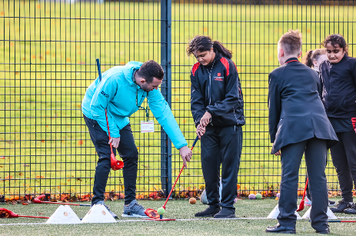
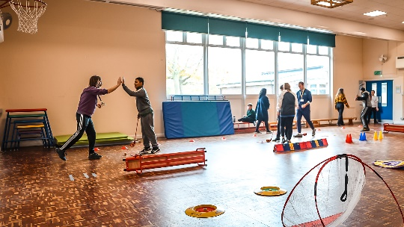

Course Synopsis
The training course has been developed by Majesticks GC and Complete PE to cater for all levels of knowledge and experience in delivering golf activities within schools.

Mainly practical-based, the outcomes for teachers and educators following the Little Sticks training course are:

- Develop staff confidence and competence in delivering golf-related activities within school, both within the curriculum and as an extra-curricular opportunity
- Ensure golf activities will be delivered in a fun and safe environment within a school setting
- Schools receive the necessary tools to deliver our Little Sticks programme (equipment, resources, support)
- Schools gain awareness of Majesticks GC and future opportunities with the team


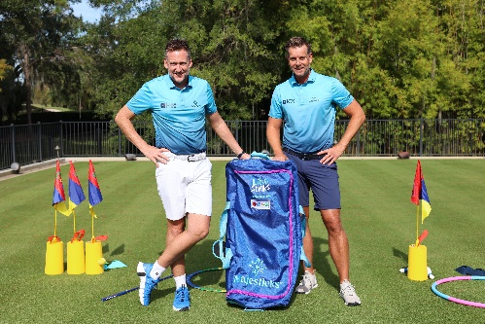

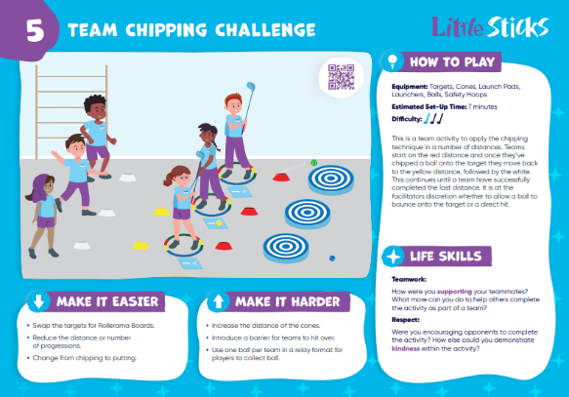

Course Training Information

The training has been arranged in partnership with Leeds Well School Partnership and will be delivered by a member of the Majesticks GC team and/or a member of staff from Complete PE.

Please note: no prior golf skills or knowledge is required.

The training is predominantly practical based, so please bring appropriate attire.

Date: Thursday 20th March 2025
Timings: 09:30 – 13:00
Location: John Smeaton Leisure Centre, Smeaton Approach, Leeds, LS15 8TA

Please note refreshments will not be provided.

You will receive a Little Sticks Educator’s Guide and pack of Little Sticks activity cards to take away from the training, with the rest of the resources being available online.

Programme timeline for 2024/25 Academic Year

Activity | Oct-24 | Dec-24 | Feb-25 | Mar-25 | Apr-25 | May-25 | Jun-25 | Jul-25
Receive programme information | /
Majesticks GC Bag Design Competition | / | /
Complete Pre-Course Teacher Survey |  |  | /
Attend Training |  |  | /
Complete Post-Course Teacher Survey |  |  | /
Receive Equipment |  |  | /
Student Pre-Programme Surveys |  |  |  | /
Delivery within KS2 PE Curriculum |  |  |  |  | / | / | / | /
Summer Little Sticks Festival |  |  |  |  |  |  | /
Student Post-Programme Surveys |  |  |  |  |  |  |  | /

Receiving Your Equipment, Next Steps and Mentorship
Upon attending the training, we will authorise the shipment of your equipment which will arrive at the school within five working days of the training date. A signature will be required to accept the goods.

If you do not receive the equipment within five working days, please email littlesticks@majesticksgc.com so we can locate the equipment in a timely manner.

Additionally, you will be given a login to the Complete PE website where you can access the golf units of work as well as the additional Little Sticks resources in the “NGB Support” section of the website.

Finally, to support your on-going development, you will receive support from a mentor to enhance your development in delivering Little Sticks in schools. Each school is entitled to three support visits in your first 12 months of delivering the programme and you’ll be given feedback following each visit.

Monitoring and Evaluation
We have embedded monitoring and evaluation into the programme, in order to measure the impact on young people and teachers.

Schools are required to use the QR codes or URL links provided to survey your students before they take part in the programme and at the end. Each school will receive a Programme ID code to reference when using the surveys.

Additionally, we have set up a teachers survey to measure the impact of the training and mentoring for educators’ confidence and competence at delivering golf in schools. Teachers are required to complete the short survey throughout their initial 12 months including: Pre-Programme; Post-Programme; 3 months; 6 months; 12 months.

Please complete the Pre-Training survey link here, before the training date using your Programme ID code or school name as reference.

Majesticks GC will send you the school information in a report at the end of the academic year.

If you require any information, or want to send us some feedback from delivering the programme, we’d love to hear from you at littlesticks@majesticksgc.com.

